
CENTRAL WEST EDUCATION DIVISION

2026 MALAWI CERTIFICATE OF EDUCATION
MOCK EXAMINATIONS
CHEMISTRY
PAPER I
( 100 marks) Subject number: M038/II
Thursday, 19th March Time allowed: 2 hours
8:00am – 10:00am

INSTRUCTIONS
- This paper contains 11 printed pages, please check
- Write your candidate number on each and every page of the question paper
- This paper contains two sections A and B. Answer all questions in both sections in the spaces provided.
- Use of electronic calculators is allowed.
- Hand in your paper to the invigilator when time is called off.

Question No | Tick if answered | Do not write in these columns
1
2
3
4
5
6
7
8
9
10
11
12
13
 | TOTAL

SECTION A (70 Marks)
Answer all questions in this section in the spaces provided
- a. Mention any one use of synthetic polymer in relation to their property.
________________________________________________________________________________________________________________________________________________ (2marks)
b. Explain why branched isomer of an organic compound has low boiling point than their corresponding straight isomers.
________________________________________________________________________________________________________________________________________________ (2 marks)
c. State any one use of alkanals.
________________________________________________________________________ (1 mark)
- a. Figure 1 below shows electrolysis of Copper Sulphate using graphite electrodes.

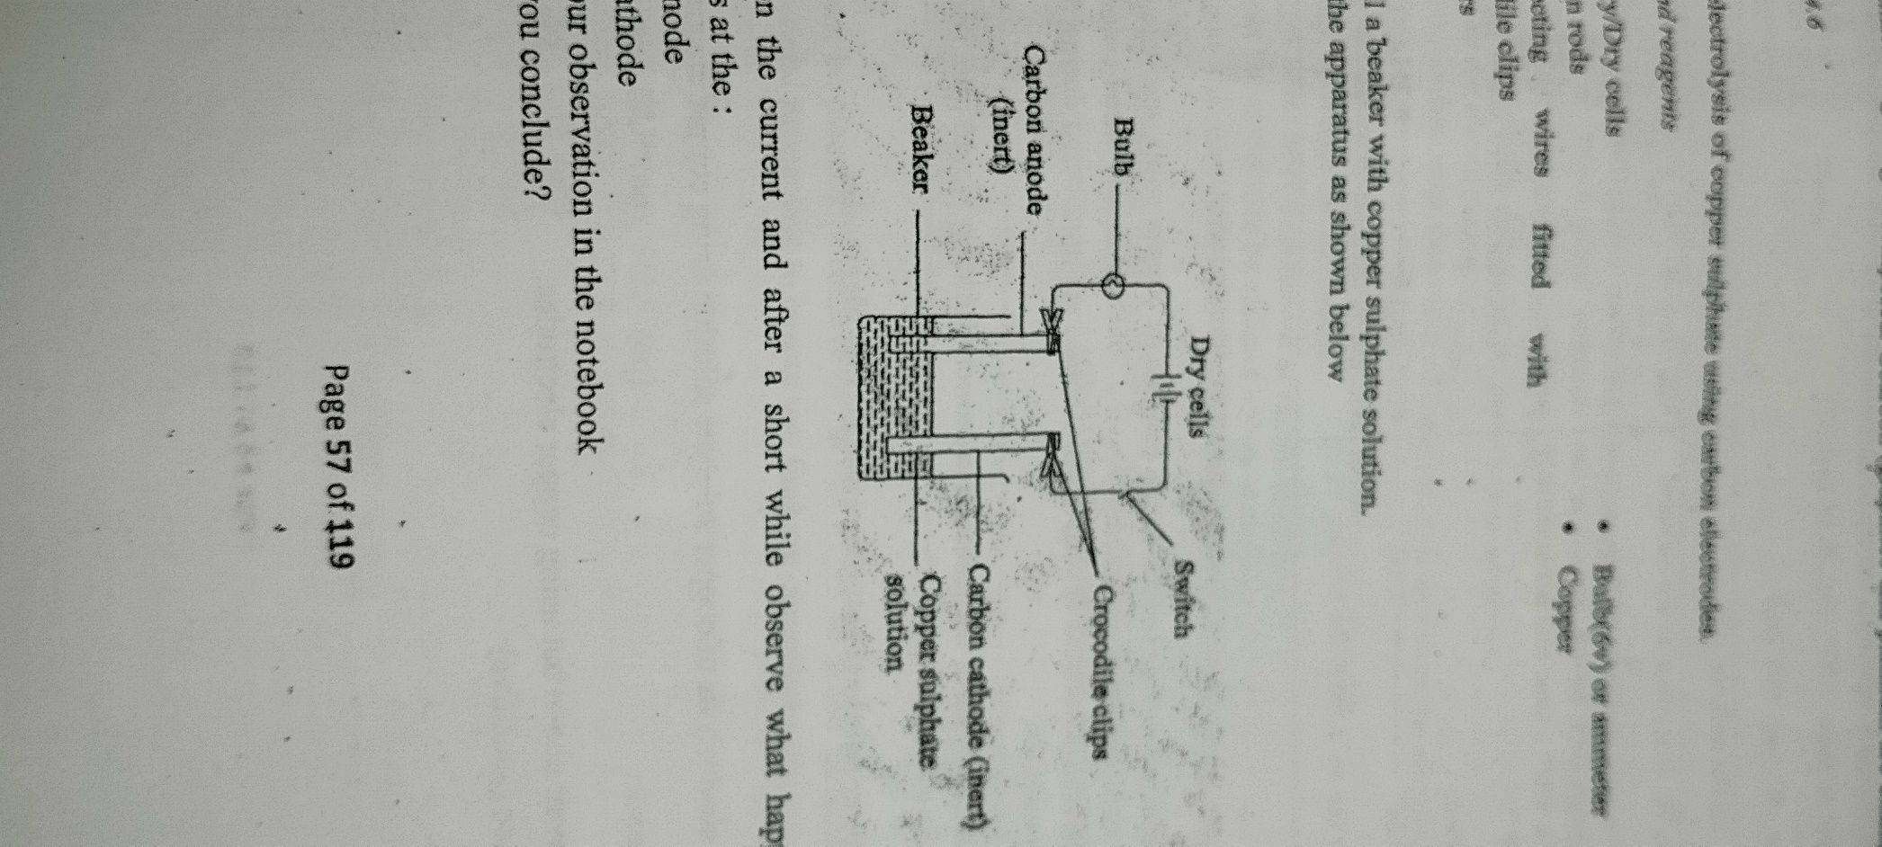
i. Write down half equations at
Anode: _______________________________________________________(1 mark)
Cathode: ______________________________________________________(1 mark)
ii. Write down an overall equation for the reaction in the diagram.
__________________________________________________________________________________________________________________________________________ (2 marks)

b. Mention one application of precipitation reaction.
______________________________________________________________________ (1 mark)
c. Mention any one reagent used to identify cation.
______________________________________________________________________ (I mark)
- a. State any one use of brass
________________________________________________________________________ (1 mark)
b. Explain how hydrogen bonding occurs.
________________________________________________________________________________________________________________________________________________ (2marks)
c. State importance of Ozone layer.
________________________________________________________________________ (1 mark)
d. Explain how lime is used in treating water acidity.
________________________________________________________________________________________________________________________________________________________________________________________________________________________ ( 2marks)
e. Give any one structural difference between ionic compound and covalent compounds.
________________________________________________________________________________________________________________________________________________ ( 1mark)
- a. Explain how galvanization is used to prevent rusting.
________________________________________________________________________________________________________________________________________________________________________________________________________________________________________________________________________________________________________________________________________________________________________________________________________________________________________________ (3 marks )
b. Give any two similarities between Silicon dioxide and diamond.
________________________________________________________________________________________________________________________________________________________________________________________________________________________________________________________________________________________________________________________________________________________________________ (2marks)
c. Explain the formation of ammonium nitrate fertilizer.
________________________________________________________________________________________________________________________________________________________________________________________________________________________________________________________________________________________________ ( 2 marks)
- a. Figure 2 below shows structures of organic compounds P,Q,R and S
P Q
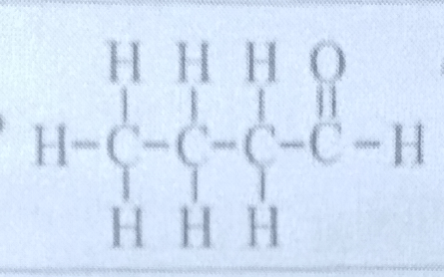
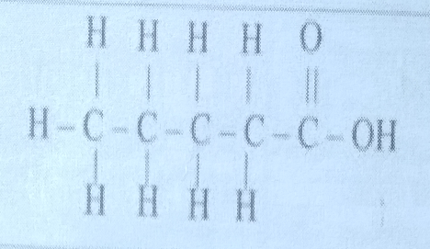
R S

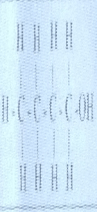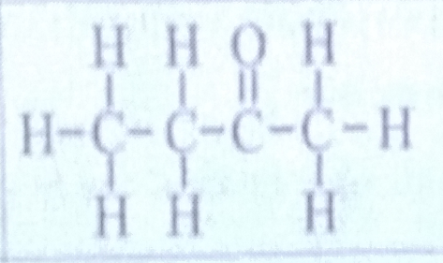
i. Identify organic compounds represented by structures Q and S
Q ____________________________________________________________(1mark)
S ____________________________________________________________(1 mark)
ii. Describe an experiment that could be conducted to identify organic compounds P
and R.
_____________________________________________________________________ _____________________________________________________________________ _____________________________________________________________________ _____________________________________________________________________ _____________________________________________________________________ _____________________________________________________________________ _____________________________________________________________________ _____________________________________________________________________ _____________________________________________________________________ _____________________________________________________________________ (4 marks)
b. Draw two positional isomers of butene C₄H₈.

( 4 marks)
- a. State any two ways of expressing concentration
__________________________________________________________________________________________________________________________________________________ (2 marks)

b. An 18g of MgSO₄ table was completely dissolved in 150 ml of water.
i. Calculate the number of moles of MgSO₄ in the tablet (RAM: Mg = 24, S = 32, O = 16)

(3 marks)
ii. Calculate the Molarity of the solution made.

(3 marks)
c. Explain how boiling softens hard water.
________________________________________________________________________________________________________________________________________________________________________________________________________________________________________________________________________________________________________________________________________________________________________ (2 marks)
- a. Below is the sample Chromatogram for substances L, M, and N

L M N
i. On the diagram label the solvent front. ( 1 mark)
ii. Identify one impure substance in the diagram
_____________________________________________________________________ (1 mark)
iii. Use a ruler to measure relevant distances and calculate the Relative Flow value for substance M.

(3 marks)
b. Describe how sulphur dioxide gas can be identified using acidified potassium dichromate
________________________________________________________________________________________________________________________________________________________________________________________________________________________________________________________________________________________________________________________________________________________________________ (3marks)
- a. Explain any one effect of extensive burning of organic fuels.
________________________________________________________________________________________________________________________________________________ (2 marks)
b. Give any one example of waste product from chemical reactions.
_____________________________________________________________________ (1mark)
c. Explain any two differences between thermosetting and thermos softening plastics.
________________________________________________________________________________________________________________________________________________________________________________________________________________________________________________________________________________________________ (2 marks)
- a. State any two uses of Phosphoric acid
________________________________________________________________________________________________________________________________________________ (2 marks)
b. Define amphoteric oxide.
________________________________________________________________________________________________________________________________________________ (1 mark)
c. Explain how the type of electrodes used in a circuit affect preferential discharge.
________________________________________________________________________________________________________________________________________________________________________________________________________________________ (2 marks)
- a. Below is an equation for the reaction between hydrogen gas and chlorine gas
H_{2(g)} + Cl_{2 (g)} 2HCl _{(g)}
Write down the following:
- Oxidation half equation

_________________________________________________________(1 mark)
- Reduction half equation

__________________________________________________________1 mark
b. Draw the structure of a hydronium molecule H₃O⁺ and show a dative bond.

( 2marks)
c. Calculate the oxidation number of Carbon in NaHCO₃

(3marks)

SECTION B ( 30 marks)
Answer all questions in the spaces provided
- a. Describe how ion exchange method is used to remove permanent water hardness. __________________________________________________________________________________________________________________________________________________________________________________________________________________________________________________________________________________________________________________________________________________________________________________________________________________________________________________________________________________________________________________________________________________________________________________________________________________________________________________________________________________________________________________________________________________________________________________________________________________________________________________________________________________________________________________________________________________________________________________________________________________________________________________________________________________________ (5 marks)
b. Describe the process of recycling metals.
_________________________________________________________________________________________________________________________________________________________________________________________________________________________________________________________________________________________________________________________________________________________________________________________________________________________________________________________________________________________________________________________________________________________________________________________________________________________________________________________________________________________________________________________________________________________________________________________________________________________________________________________ (5 marks)
- a. With the help of chemical equations, describe the preparation of ethanoic acid (CH₃COOH) using oxidation.
___________________________________________________________________________________________________________________________________________________________________________________________________________________________________________________________________________________________________________________________________________________________________________________________________________________________________________________________________________________________________________________________________________________________________________________________________________________________________________________________________________________________________ ____________________________________________________________________________________________________________________________________________________________________________________________________________________________________________________________________________________________________________ (5 marks)
b. Describe how an irreversible reaction can be demonstrated by decomposing Calcium Carbonate (CaCO₃)
____________________________________________________________________________________________________________________________________________________________________________________________________________________________________________________________________________________________________________ ________________________________________________________________________________________________________________________________________________________________________________________________________________________________________________________________________________________________________________________________________________________________________________________________________________________________________________________________________________________________________________________________________________________________________________________________________________________ (5 marks)
- Describe an experiment that can be carried out to investigate the effect of surface area on the rate of reaction.
___________________________________________________________________________________________________________________________________________________________________________________________________________________________________________________________________________________________________________________________________________________________________________________________________________________________________________________________________________________________________________________________________________________________________________________________________________________________________________________________________________________________________ ____________________________________________________________________________________________________________________________________________________________________________________________________________________________________________________________________________________________________________ ___________________________________________________________________________________________________________________________________________________________________________________________________________________________________________________________________________________________________________________________________________________________________________________________________________________________________________________________________________________________________________________________________________________________________________________________________________________________________________________________________________________________________ ___________________________________________________________________________________________________________________________________________________________________________________________________________________________________________________________________________________________________(10 marks)
END OF QUESTION PAPER

